Assignment 25.2

Problem Statement: Write a Hive Program to find the total number of medals each country won.

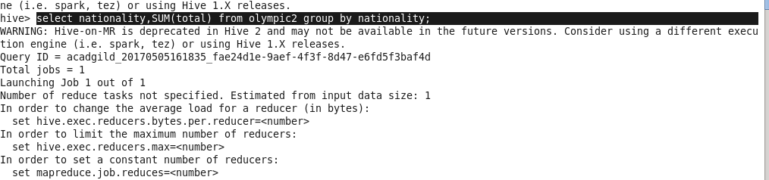

Here, command is to find the total number of medals each country won using SUM function.

Output:

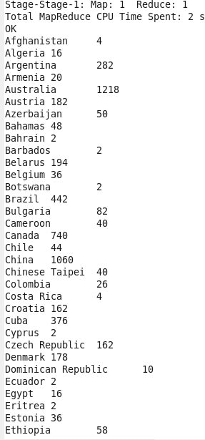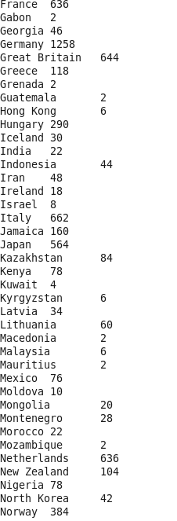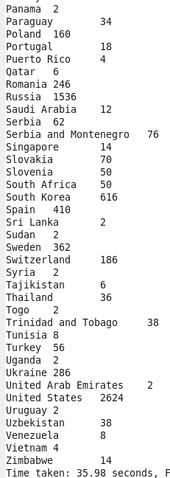

Problem Statement: Write a Hive program to find the number of gold medals each country won.

Here, command is to find the total number of gold medals each country won using SUM function with Output.

